Project Design Phase
Solution Architecture
Date | 1 October 2026
Team ID
Project Name | Import Data using Transform Maps (Spreadsheet)
Maximum Marks | 4 Marks
Solution Architecture:
This project imports employee data from a spreadsheet into ServiceNow. The data is staged in an Import Set table, validated and converted by a Transform Map, and then inserted or updated in the target Employee Test table. Its goals are to:
- Load spreadsheet data into ServiceNow without manual record entry.
- Stage data in an Import Set table and map it to the target table with a Transform Map.
- Validate imported fields (Employee ID, Name, Email, Department, Location).
- Use Coalesce on Employee ID so repeated imports update existing records instead of creating duplicates.
- Report on the imported data with a dashboard-ready chart (Employees by Department).
Solution Architecture Diagram:
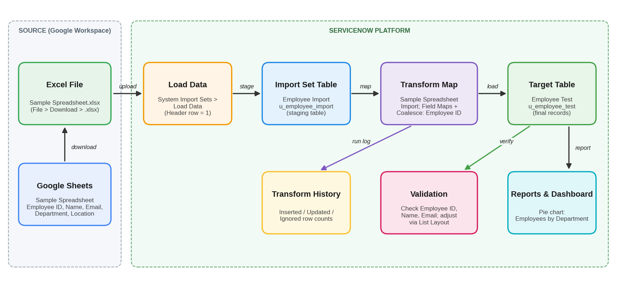
Figure 1: Architecture and data flow of the spreadsheet import using Transform Maps in ServiceNow
Components:
Component | Description
Google Sheets / Excel | Sample Spreadsheet with Employee ID, Name, Email, Department and Location, downloaded as Sample Spreadsheet.xlsx.
Employee Test table | Custom target table (u_employee_test) with String fields: Employee ID, Employee Name, Email, Department, Location.
Import Set table | Employee Import (u_employee_import): temporary staging table created through Load Data.
Transform Map | Sample Spreadsheet Import: maps source fields to target fields; Employee ID is the Coalesce field.
Transform History | Shows the number of records inserted, updated and ignored for each run.
Reports | Employees by Department: pie chart grouped by Department with Count aggregation.
Data Flow:
- Create the spreadsheet in Google Sheets and download it as .xlsx.
- Create the Employee Test table and add its form fields through Form Layout.
- Use System Import Sets > Load Data to upload the file into the Employee Import table.
- Create the Transform Map, auto-map matching fields and run Transform.
- Verify the records in Employee Test; fix field layout or data issues if needed.
- Enable Coalesce on Employee ID and re-import to confirm inserts and updates.
- Create and save the Employees by Department report.
Project Milestones:
Milestone / Story | Scope | Assigned to
1. Creation of Spreadsheet and Table | Sample spreadsheet; Employee Test table | Monika R; Priyanka D
2. Import Set Table and Transform Map | Employee Import table; Sample Spreadsheet Import map | Archana K K
3. Transform, Validate and Coalesce | Data validation; duplicate avoidance; new data in Excel format | Priyanka D; Nithyasree M; Pushpavalli B
4. Reports and Dashboards | Report 1: Employees by Department | Pushpavalli B
Reference: SkillWallet – ServiceNow System Administrator, group project "Import Data using Transform Maps (Spreadsheet)"

